

De La Salle University

College of Computer Studies

Software Technology Department

**OVPEA External Opportunities Matching System**

SOFTWARE REQUIREMENTS SPECIFICATION

|  |  |
| --- | --- |
| **Team Name** | **Team Tapia** |
| **Section** | S23 |
| **Team Members** | Avenido, Joem  Cruz, Jacob  Delgado, Alyzza May  Gapuz, Jan Allen  Hao, Anthony Lance  Lim, Regeene Melarese  Soriano, Matthew Reynaldo  Sy, Joshe Martin  Tapia, Franklin Benjamin  Velasco, Vienne Mari |
| **Date Submitted** | April 15, 2016 |

**Table of Contents**

|  |  |
| --- | --- |
| 1. Executive Summary | 1-3 |
| 1. Overview | 2-4 |
| * 1. Existing Business Process | 2-4 |
| * 1. Data Requirements | 2-7 |
| * 1. Roles in the Business Process | 2-8 |
| 1. Problem Analysis | 3-9 |
| 1. Software Solution | 4-11 |
| * 1. Objectives | 4-11 |
| * 1. Characteristics | 4-11 |
| 1. User Stories | 5-12 |
| * 1. User Story 1   2. User Story 2   3. User Story 3   4. User Story 4   5. User Story 5   6. User Story 6   7. User Story 7   8. User Story 8   9. User Story 9 | 5-12  5-12  5-13  5-13  5-14  5-15  5-16  5-16 |
| Appendix A - Improved Business Process | A-17 |
| Appendix B - Interview Transcript | B-20 |
| Appendix C - Sample Forms and Reports | C-43 |
| Appendix D - References and Acknowledgements | D-55 |

1. **Executive Summary**

The Office of the Vice President for External Affairs (OVPEA) is an office under the University Student Government of De La Salle University. The OVPEA offers a wide-range of external opportunities that the students may grab for them to further develop and grow into the different fields they want to go into.

One of the tasks of OVPEA is external opportunities matching, which caters to the needs of both the company and the students. The external opportunities can be student exchange programs, which fall under the education domain. These can also be job expositions, and internship programs, which fall under the career domain. As well as youth development and growth programs, under the government domain.

The external opportunity matching, which is specifically handled by the career services department of the OVPEA, includes the collating of lists of external opportunities coming from the Office of Counseling and Career Services (OCCS) and External Relations and Internationalization Office (ERIO), checking the qualifications of the external opportunities, screening and filtering the external opportunities, matching the external opportunities to specific colleges they are applicable to, publicizing these external opportunities to the student body, and tracking and redirecting students to other external opportunities if they were able to get the opportunities they have applied to.

1. **Overview of the Business Process**

**2.1 Existing Business Process**

The Office of the Vice President for External Affairs (OVPEA) provides external opportunities matching for the companies and students, bridging them together. External opportunities are categorized in 3 categories - education, career, and government opportunities.

For education, the process starts with the external linkages research manager gathering all the exchange program opportunities from the dlsu e-mail which are e-mailed by the External Relations and Internationalization Office (ERIO). After gathering, the research manager sorts the exchange program opportunities by country. Then, the research manager checks if these opportunities are fitting for the students and to which courses they are applicable to. Based on the courses, the research manager identifies to which colleges these opportunities could be offered. The research manager then filters the external opportunities based on the deadline of the application. If the deadline is within a month or less, the opportunity will be removed from the collated list. After filtering, the research manager will now organize the requirements that will be needed for the application. The advertising manager will prepare a layout for the whole publicity material and certain details about the external opportunity will be included in the publicity material. Afterwards, the publicity material will be approved by the director or ERIO or by the Vice President of External Affairs. Once the publicity material is approved, the OVPEA will publicize the external opportunities by blasting publicity materials in different facebook groups. When a student sees these publicity materials, he or she could contact the person in-charge of a specific external opportunity then the student applies to this opportunity. If the student contacted the person in-charge which is indicated in the publicity material, the student will be required to write down his details on a log sheet for tracking purposes which is provided by the OVPEA. The student could also follow up with the OVPEA if he or she got the opportunity. If the student does not follow up, the process ends. If the student follows up with the OVPEA and got the opportunity, the process terminates, however, if the student did not get the opportunity, the student could ask for other external opportunities they could apply to. If the student asks the OVPEA, the OVPEA informs the student of other external opportunities he or she could apply to then the student may or may not apply to it. If the student does not want to apply to the other opportunity offered by the OVPEA, the process ends. If the student would want to apply to that opportunity, the process goes back to contacting the person in-charge and undergoes to the same flow as seen in the business process shown in figure 2-1.

For career, the process starts with the Office of Counseling and Career Services (OCCS) giving a prepared list of external opportunities (e.g. company internships) or the companies directly contacts the OVPEA to inform about opportunities they are offering to DLSU students. In the case of companies directly contacting the OVPEA, either the companies are asking for publicity efforts or would want to be included in the listing of OCCS for Job Expos. If a company only asks for publicity efforts, the company is automatically included in the pool of companies that will be collated along with the prepared list by the OCCS. Once the list is collated, the research manager sorts the company opportunities by country and then so on as seen in figure 2-1. If a company would want to be included in the listing of OCCS for the Job Expos, the career services department gets first the company profile and give it to OCCS for further processing. Once a company is approved by and included in the listing of OCCS, the career services department starts to organize the requirements needed for the application in the opportunity offered by that company and then so on as seen in figure 2-1.

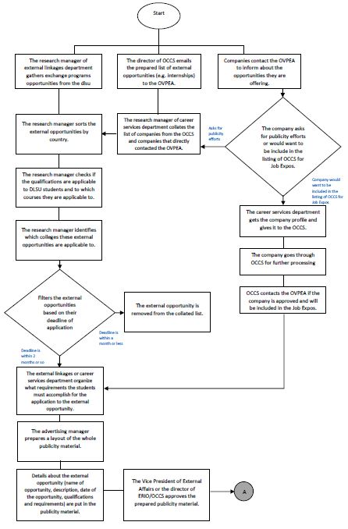

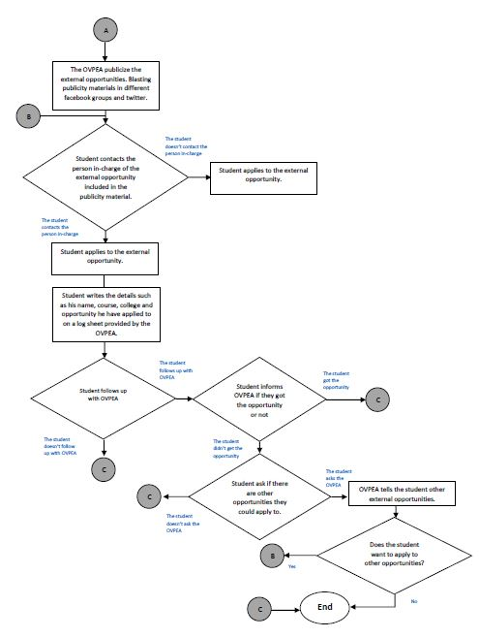

Figure 2-1. Existing Business Process

**2.2 Data Requirements**

A list of external opportunities (see Appendix C-1 and Appendix C-2) that is given by the Office of Career and Counseling Services (OCCS) for the career-related opportunities and the External Relations and Internationalization Office (ERIO) for the student-related opportunities that contains the following information:

**Career-related opportunities under OCCS**

* Opportunity Number
* Opportunity Name
* Company Name
* Country
* Type of Opportunity (“Employment” or “Internship”)
* Kind of Opportunity (in this case, “Career”)
* Duration
* Requirements
* Salary (if applicable)
* Contact Person
* Other Details
* Status (“Open” or “Closed”)

**Company details**

* Company Number
* Company Name
* Company Address
* Company Link
* Contact Number

**Student-related opportunities under ERIO**

* Opportunity Number
* Opportunity Name
* Academe Name
* Country
* Type of Opportunity (“Student Exchange Program”)
* Kind of Opportunity (in this case, “Student”)
* Duration
* Requirements
* Programme
* Deadline of Application
* Other Details
* Contact Person

**Academe details**

* Academe Number
* Academe Name
* Academe Address
* Academe Link

The Matching System should be able to match opportunities, whether it may be Career or Student depending on a student’s (user) college and batch.

A sign up sheet or tracking sheet (see Appendix C-4) contains the list of the students who applied for a certain opportunity and the corresponding opportunity they have applied to.

**Tracking details**

* Tracking Number
* Tracking Start Date
* Tracking End Date
* Student Name
* Opportunity Number
* Status (if a student has been accepted, rejected or the application is still in progress)

A Research Manager should be able to have an account to login into the system to add or update opportunities. A Research Manager should also be able to track the students on their applications and modify the status of each tracking record. In addition, A Research Manager should be able to add accounts as Research Managers in the system.

**Account details**

* Username
* Password
* Account Name
* Account Type (“Administrator”)
* Last Login

**2.3 Roles in the Business Process**

Various students and personnel are involved in the business process of external opportunities matching. The roles of the students and personnel and their tasks are summarized in Table 2-1.

|  |  |
| --- | --- |
| Role | Description of Tasks |
| Applicant | * Fills up the tracking sheet |
| Career Services (CS) Department Chairperson | * Screens and filters the opportunities in the list * Determines if the opportunity is a publicity effort or if it wants to get inside the university * Redirects the applicant to another opportunity if rejected |
| OCCS Head | * Gives the paper-based list of opportunities to the CS Department chairperson * Processes the requirements for the company that wants to get inside the university |
| ERIO Head | * Gives the paper-based list of opportunities to the CS Department chairperson |

Table 2-1. Student and Personnel Roles and Tasks in External Opportunities Matching

1. **Problem Analysis**

In the current process of External Opportunities Matching by the career services department under the Office of the Vice President for External Affairs (OVPEA), the Research Manager of the career services department and the other department members, the monitoring and matching of opportunities are inefficient and ineffective, due to the fact that, matching are done manually and the monitoring and the organizing of opportunities are not systematic, in which, leads to several impacts.

|  |  |  |  |  |
| --- | --- | --- | --- | --- |
| **ID#** | **Description**  What’s the problem? | **Cause**  What causes the problem? | **Symptom**  How do we know the problem exists? | **Impact**  Why is this important? What are the consequences? |
|  |  |  |  |  |
| 1 | * The career services department finds it difficult to monitor the students who applied for a certain opportunity. | * There is no consistent/systematic way of monitoring the students who already applied for the opportunity. * Students do not inform the career services committee if they already applied for an opportunity. | * The career services department does not know when to inform the students if an opportunity is already full or no longer available. | * The students will not know if he/she can still apply to a certain opportunity. * Missed opportunity. |
| 2 | * The career services department under OVPEA encounters difficulty in matching external opportunities to which colleges they are applicable to. | * The given qualifications and specifications of the external opportunities sometimes apply to students in different colleges, so it is overlapping or confusing. | * Some students that meet the qualifications of an external opportunity and could apply for it are informed late or not at all. | * Students will have limited opportunities to apply to if not matched properly. * Missed opportunity for students that are qualified for it. * The career services department match an opportunity not applicable to a certain college |
| 3 | * Students are not well informed of the different opportunities offered by the university | * The students do not check their DLSU emails and look for external opportunities offered by the university. | * Some students were not able to apply to these opportunities. * There are currently available external opportunity demands from the students. | * Missed opportunity. * The efforts of the career services department are wasted |
| 4 | * Students apply for an opportunity that are not fit for them. | * Qualifications or requirements of the opportunity are too vague or too general | * The students waste time/effort in applying for an opportunity that is not for them. * The students discovers the opportunity after the deadline. | * Missed opportunity. * The students does not know if he/she can still apply to the opportunity. |

With the problems being stated regarding the inefficiency and ineffectivity or the current process of External Opportunities Matching, the proposed software solution to the problem is an external opportunity matching system, in which, it is a system that is reachable to the students, wherein the students will be able to access it online. It is for them to see different opportunities that they can avail or apply to that they did not really know that was offered to them by the university. The goal is for the students to be able to have an idea of different possibilities they could get even if it was offered to them before, but with the system it is more organized and more systematic ways for them to grab these opportunities.

1. **Software Solution** 
   1. **Objectives**

The External Opportunities Matching System aims to provide the students or applicants to have an idea of the different possibilities they could apply to external opportunities with a more organized and more systematic process.

The specific objectives of the software are as follows:

* To provide a facility for managing the list of external opportunities;
* To provide a facility for tracking the status of the external opportunities;
* To provide a facility for tracking the requirements and qualifications of the external opportunities;
* To provide a facility for matching the external opportunities to specific colleges;
* To provide a facility for a systematic approach regarding inquiries of students;
* To generate various reports for monitoring the status and categories of external opportunities
  1. **Characteristics**

The External Opportunities Matching System is aimed to be Accessible, User-friendly and Reliable. Accessibility is one of the characteristics of the External Opportunities Matching System since information may be useless if the system is not readily available. In addition, the system should be easily accessed online so that it may be accessed in private homes. Also, the system is aimed to be User-friendly or easy to operate, in which, the processes that the system follows is not complex, thus, leads to user efficiency and user satisfaction. Furthermore, the system is reliable, in which, the information provided by the system is complete and consistent to prevent incorrect disseminated information.

1. **User Stories**

|  |  |
| --- | --- |
| User Story #1: The Research Manager can login to the system to perform his/her tasks. | |
| Estimate (Days): 2 days | Priority: 70 |
| Pre-condition: The Research Manager has an existing account. | |
| Scenario:  1. The Research Manager provides his/her username and password.  2. The system checks the database if the user exists.  3. The system checks the database if the username and password match. | |
| Post-condition: The system redirects the user to his/her dashboard. | |
| Acceptance Criteria:  1. Verify that the password has a minimum length of 6 characters, and does not contain any special characters.  2. Verify that the user exists in the database.  3. Verify that the username and password match.  4. Verify that the system displays the dashboard of the correct user. | |

|  |  |
| --- | --- |
| User Story #2: A Research Manager can add an external opportunity. | |
| Estimate (Days): 3 days | Priority: 70 |
| Pre-condition[K1] : A Research Manager is on the “add opportunity” page. | |
| Scenario:[K2]  1. The system displays the list of external opportunities.  2. A Research Manager fills out a form with the college, country, opportunity name, company name, description, qualifications, requirements, application period. All of which are required fields.  3. The system checks the database if the external opportunity exists. If it does exist, the system notifies the Research Manager. Otherwise, it adds the opportunity to the database. | |
| Post-condition: The system displays the list of external opportunities. | |
| Acceptance Criteria:  1. Verify that the system displays the list of external opportunities from newest to oldest.  2. Verify that the system displays the opportunity name on each row.  3. Verify that all required fields are filled out.  4. Verify that an external opportunity has been successfully added to the database. | |

|  |  |
| --- | --- |
| User Story #3: A Research Manager can set the status of an external opportunity to open, closed, extended. | |
| Estimate (Days): 2 days | Priority: 70 |
| Pre-condition: A Research Manager has checked the details of an external opportunity (e.g. no. of applicants, application period). | |
| Scenario:  1. The system displays the list of external opportunities.  2. A Research Manager selects an opportunity to view the details.  3. A Research Manager views the previous status of an external opportunity.  4. A Research Manager changes the status of an external opportunity.  5. The system asks for confirmation.  6. A Research Manager confirms the changes.  7. The system saves the changes to the database. | |
| Post-condition: A Research Manager is redirected to the detailed view of an external opportunity. | |
| Acceptance Criteria:  1. Verify that the system displays the list of external opportunities from newest to oldest.  2. Verify that the status is changed[K4] to only open, closed, or extended. | |

|  |  |
| --- | --- |
| User Story #4: A student can view the list of an external opportunities to know what he/she can apply for. | |
| Estimate (Days): 5 days | Priority: 70 |
| Pre-condition: A student is at the homepage | |
| Scenario:  1. The system displays the list of the external opportunities from latest to earliest  2. A student can select an external opportunity to view more details. | |
| Post-condition: A student is redirected to the main page of the external opportunity. | |
| Acceptance Criteria:  1. Verify that the system displays the list of the external opportunities and can be sorted by date and time, country, college, newest to oldest.  2. Verify that each external opportunity displays the publicity material with the following details: opportunity name, company name, company contact details, description, and application period.  3. Verify that the account logged in is a Research Manager | |

|  |  |
| --- | --- |
| User Story #5: A student can submit an inquiry with regard to their concerns about an external opportunity. | |
| Estimate (Days): 2 days | Priority: 50 |
| Pre-condition: A student is within the detailed view [K6] of an external opportunity. | |
| Scenario:  1. The system displays a comments section.  2. The student can write their queries in the comments section.  3. The system adds the comment to the database. | |
| Post-condition: A student is still within the detailed view [K7] of an external opportunity. | |
| Acceptance Criteria[K8] :  1. Verify that the system displays the comments section with the list of comments from newest to oldest.  2. Verify that the comments has the message and a timestamp.  3. Verify that the system displays the comment box. | |

|  |  |
| --- | --- |
| User Story #6: A Research Manager can manage the comments. | |
| Estimate (Days): 2.5 days | Priority: 50 |
| Pre-condition: A Research Manager is within the comments section management page. | |
| Scenario:  1. The system displays the list of comments.  2. A Research Manager selects should be able to delete a comment. | |
| Post-condition[K9] : A Research Manager is still within the comments section management page and the comments are managed. | |
| Acceptance Criteria:  1. Verify that the system displays the comments by date and time.  2. Verify that a Research Manager can delete a comment.  3. Verify that a Research Manager can answer a comment. | |

|  |  |
| --- | --- |
| User Story #7: A student can write his/her name on the student tracking section. | |
| Estimate (Days): 2.5 days | Priority: 50 |
| Pre-condition: The student is within the detailed view of the external opportunity. | |
| Scenario:  1. The system displays the list of external opportunities.  2. The student selects an external opportunity he/she wishes to apply for.  3. If the student wants to apply, he/she fills out a form with his name, ID number, college, contact details. Otherwise, he/she can go back to the list of external opportunities. | |
| Post-condition : The student is redirected to the list of external opportunities. | |
| Acceptance Criteria:  1. Verify that the student can fill out a form.  2. Verify that the tracking details of a student is stored in the database. | |

|  |  |
| --- | --- |
| User Story #8: A Research Manager can update a field of an opportunity | |
| Estimate (Days): 2.5 days | Priority: 60 |
| Pre-condition: The Research Manager is logged in. | |
| Scenario:  1. The system displays the list of external opportunities.  2. The Research Manager wants to edit an information of an opportunity  3. The Research Manager saves the information | |
| Post-condition : The Research Manager is redirector to the list of external opportunities. | |
| Acceptance Criteria:  1. Verify that the external opportunity is updated.  2. Verify that the updated opportunity is updated in the database. | |

|  |  |
| --- | --- |
| User Story #9: A Research Manager can update the username or password of the Research Manager account | |
| Estimate (Days): 2.5 days | Priority: 60 |
| Pre-condition: The Research Manager is logged in. | |
| Scenario:  1. The system displays the account page of the Research Manager.  2. The Research Manager updated the username or password.  3. The Research Manager saves the new username or new password. | |
| Post-condition : The Research Manager sees a text If the username or password has been updated. | |
| Acceptance Criteria:  1. Verify that the Research Manager can log in with the new username or password.  2. Verify that the new username or password is updated in the database.  3. Verify that the Research Manager cannot use an old username.  4. Verify that the password is only alpha-numeric. | |

**Appendix A – Improved Business Process**

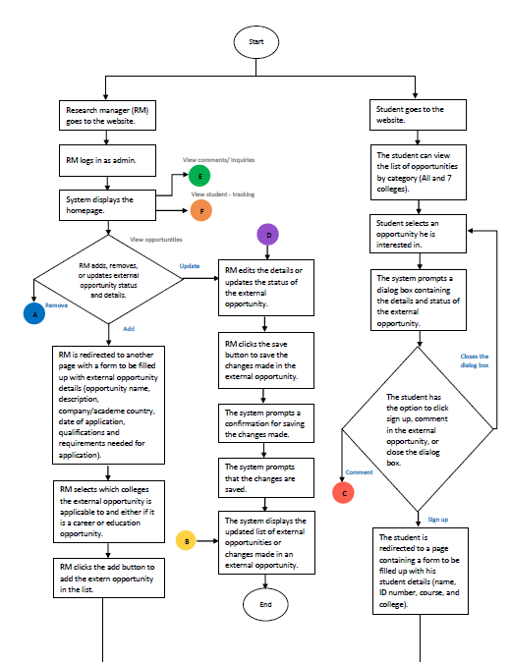

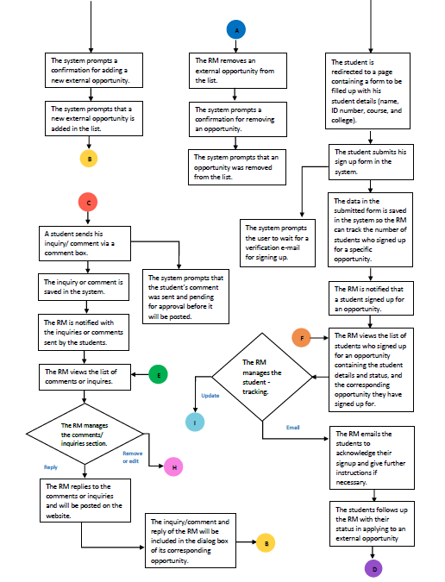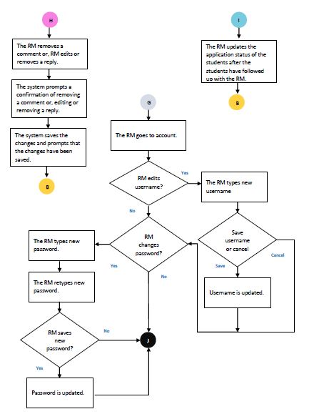

**Appendix B – Interview Transcript**

**B-1. First Interview with Levin Garcia (Vice President for External Affairs - University Student Government)**

[ I ] – Interviewer [ L ] – Levin Garcia

I: Good morning, we are from College of Computer studies. I am BJ Tapia, this is Regeene Lim and Vienne Velasco.

I: Can you please describe the work that you do?

L: Being the Vice President for External Affairs I am more of in line with different opportunities externally, different opportunities that the students could grab for them to be able to further develop with the different courses or different fields that they would want to go into. These opportunities are not limited to education itself but they are more of also like career opportunities, exchange program opportunities and government opportunities as well.

I: So how long have you been doing this work as VP for external affairs?

L: Well, I started November last year, so around 3 months.

I: Do you mind telling us about the process of external opportunities matching?

L: So basically, there are a lot of external opportunities around the university. It’s just that we don’t see it, it’s not really that catered or visible to the student body. So usually, what happens is that the opportunities go to different offices like the departments, or like the ERIO or OCCS, or sometimes already sent to our DLSU mails and with these opportunities already being shown or being catered to the students, we collate them and gather them in such a way we see and we organize them for the students, for them to really see the requirements, processes, and qualifications, for them to be able to grab these opportunities and we also get data from OCCS and ERIO to which opportunities are readily available for the students.

I: What do you consider as external opportunities?

L: External opportunity is anything actually. It can be career, education, exchange programs, government programs and basically it’s anything that could really mold the students for growth and development outside the university.

I: When you say external, is it external from the college or external from the whole University?

L: External from the whole University

I: For example you are a CCS student and you want to apply for an opportunity for CLA students. Is that allowed?

L: Sorry, so you were asking me if there is an opportunity that is catered for CLA students, and if CCS students would want to avail of that opportunity they could still get it?

I: Yes.

L: Yes they can. It doesn’t mean that if there is an opportunity catered to only a specific college then the student cannot grab it. It’s because it is also for the growth and development of the students for them to grab and try different opportunities as well.

I: So, what was the last process you did last week with regards to the external opportunities?

L: Actually right now, regarding with the external opportunities, we are currently talking to different offices regarding with the database of different opportunities in general for us to be really one, collate them. Second, is to organize specifically for which colleges they are applicable to.

I: Can you please describe the step by step process in external opportunity matching?

L: So first, what we do is that we always look and search for external opportunities in any kind, very general, like external opportunities, what the students can apply for. Second, we check the qualifications to see if an opportunity is applicable to the students. Next process, is to know the requirements and steps to follow for the students to apply for it.

I: For the processes, is it different from each college?

L: It actually depends, per college, if it’s an external opportunity given by a company which only asks who wants to go in or for publicity, it’s all the same since it’s what defines external. But there are external opportunities that comes from different offices like ERIO, OCCS, and sometimes from departments, they have their certain processes that we really have to study and really have to see if there are certain processes that need to be followed.

I: So for clarification, for external opportunities, is it only for DLSU students or the people outside DLSU can apply for it as well?

L: Well these opportunities, that’s why we get so it will cater to the DLSU students but since these publicity efforts are also open and visible to everyone then they can easily grab these opportunities. Not unless if it is processed through departments or different offices of the University.

I: How do you find the opportunities, do you e-mail, call, etc?

L: Usually through email. Usually we get these opportunities from students who are already taking their internships in different companies or students who have already graduated contact me for them to be really able to publicize inside the university.

I: So there’s no formal way for you or your office to know that there’s this company looking for applicants? Is it only through personal contact.

L: Yes, personal contact

I: So who is the one in-charge to look for opportunities?

L: Well more or less I’m one of them, and then next would be my career services department.

I: When accepting or publicizing opportunities, are there forms that has to be filled up or once someone tell you about the opportunity for a certain company, it’s automatically posted?

L: Sorry, what do you mean forms?

I: Like application forms.

L: Oh for them to be able to get in and publicized? If an opportunity is just a publicity effort, that’s immediately going to be publicized. Although it’s more of us screening and organizing the requirements and the steps they have to take, that’s immediate for publicity efforts. But for companies that would want to get into let’s say, Job expos, seminars inside the university, they still have to through OCCS for them to check and see, if one, if they are part of the list of companies that they have, and second is, for them to be able to endorse and give them the process what they have to do.

I: So do you have any criteria when you screen the external opportunities or something like a list of it?

L: Well, there is no criteria like certain criteria on how we screen or which to get as of the moment. Cause the criteria is more of the qualifications for them, if we see the qualification is fitting for the students and if they would be able to really maximize their stay in that company. Immediately, we would be able to take into consideration that company.

I: So what information do you need to keep track of, like the company name, details and etc?

L: Okay, so usually when we track or monitor these companies, of course the company name, address, their openings, qualifications of their openings, contact details.

I: Do they release like yung salary?

L: No, it’s very confidential. One, we also don’t get that information from different companies not unless they state that salary are given to interns or students, or allowance not unless if they state it. But with that, we really take into consideration confidentiality.

I: So was there ever inaccurate or incorrect information encountered when a student was applying but he/she was given the incorrect requirements?

L: Usually it’s more of a student was not qualified. It’s just that at some point in time with different opportunities, different blastings, different people see the publicty. Sometimes applications are not considered because of the lack of information and awareness to the different opportunities by the students at that exact time when it was released.

I: So there are slots per opportunity?

L: Yes, a company says how many they need, however, we can’t limit. For example we got four people already, we can’t limit it there. Because sometimes the company wants to see different people as well, to check the variety and skills they are looking for which matches the job description.

I: How about the qualifications of the students. For example, if I saw your publicity and I applied, do I get accepted immediately or what?

L: When it comes to the qualifications for a student, honestly, the qualifications they need to abide by and see if they’re fit for it are the qualifications of the company, we have don’t really have qualifications as the office but then our rules is more of us being able to offer them these opportunities and bridge them to the companies.

I: So the company is the one that approves?

L: Yes, more or less they are.

I: So what do you do if these students applied and got rejected? Do you publicize again about this opportunity?

L: When it happens, of course the companies would want publicity, because they’re still looking for interns or students that they want and would get for their company. However, for students who got rejected, it’s very sad, however, that’s why we have the different database and different information from different companies for us to be able to really see, okay if you fit for this company maybe for another company you would be fit for that. So somewhat we redirect them to different companies that they can apply for.

I: So how do you do that? Email or text, how do you inform them?

L: Usually it’s more of a personal talk. I talk to them and tell that we’re sorry that they were not accepted.

I: What’s the most difficult process for you in the whole matching?

L: It’s more of really organization and really making it very specific to the different students, colleges and batches. It’s because, a lot of people, we could say that external opportunities are very general, however, there are different qualifications that the companies are looking for. It’s very hard for us to be able to really give out and cater to specific colleges and students with the big number of companies in the database. So it’s more of about organization, matching, and screening or filtering. That’s the hardest part, I guess.

I: So how do you handle that?

L: Honestly, it still cannot be solved now. It’s more of us being able to just really publicize and give out the opportunities. Because I just started 3 months ago so it’s kinda hard for me to be able to really start and really execute immediately with our plans, however, but slowly and surely we’re planning to be more organized and for us to be able to give out the students opportunities that are more specific andfor their qualifications.

I: Has this been a problem ever since?

L: I believe so it has been a problem.

I: Can you give us examples of the problems that you’ve encountered with that?

L: Last term, I was working for Nestle, I was an intern for 6 months until December and then we had openings for different specifications and then so I emailed, actually blasted publicity efforts and messages, so the different DLSU groups mainly jobs and internship opportunities groups on Facebook, some applied and contacted me regarding the opportunities. The problem there was, sometimes a company looks for certain skills and certain qualifications that’s why some students don’t get accepted and one problem I encountered during that experience, is that after the interview of the students with Nestle or a company, it’s more of the follow up regarding if the person got the slot or not. Sometimes a company takes long to be able to reply. I guess that’s one thing that we’re working on, more of company relations when it comes to us communicating with them, for us to be able to disseminate the information to students who got the opportunities.

I: Can you be more specific about the external opportunities, like for education what could be these opportunities, like exchange programs and etc?

L: For education, it’s more of exchange programs abroad or even exchange programs outside the University, like exchange programs with different Universities in Metro Manila or exchange programs for a term abroad wherein other subjects can be credited in to their curriculum. For career, it’s more of internships to their specified field on what they would want. For example, for CLA students, for communication majors, an internship last year offered was internship with ABS-CBN for them to be able to really practice their skills and learnings outside the classroom. For government, it’s more of them being able to have that opportunity to be a part of a government office.

I: Are conferences or conventions offered by different companies included in the criteria of an external opportunity?

L: Sometimes, however, it’s more of, how should I say this? Usually conferences are a partnership between CSO and OCCS and different organizations because therationale on that having it a partnership is for us to be able to reach more people, for us to be able to organize and lessen redundancies when it comes to these processes

I: So for example there is a system already, will the conferences be published there?

L: It can be published but it’s stil upon the discretion of the different organizations that we really have to coordinate and collaborate with.

I: When it comes to the matching system itself, what do you envision in your system or what is your goal for the system?

L: I envision a system wherein the student will be able to access it, to be reachable to the students, that it’s just a few clicks away for them to see different opportunities and different things that they can avail of that they didn’t really know that was offered to them by the University and for the goal is that the students be able to one, to have an idea of different possibilities they could get even if it was offered to them before, but with the system it is more organized and more systematic ways for them to grab these opportunities.

I: So with the system, what I understood was the student inputs his batch and college then he could see all the available opportunities?

L: Yes, more or less.

I: So you want that they could apply through the system or submit their application form?

L: Oh when it comes to the application forms and requirements, we can, however, if we already have that system and we add an option for us to be the one to process their application, I think it wouldn’t be ideal since the students could be more dependent on us. So I don’t want that to happen. I want the students to utilize this avenue to maximize their skills and qualities by themselves, but this is an avenue for them to really grab these opportunities.

I: So how are you informed if a student wants the opening?

L: So you mean how do you track if the students was able to get the opportunity? Well I guess that is something I would also want in the system. For us to be able to really monitor properly.

I: So right now, there is no way to track the applicants?

L: None. It’s more of them when they see the publicity efforts, they approach us and tell us if they can apply, so that’s how we monitor, it’s kinda hard, well sometimes students don’t tell us that they already applied for that certain opportunity, so we don’t know whether if we should take or inform everyone that the opportunity is already taken or full. So that is what’s hard when it comes to the announcements.

I: In submitting the requirements, can a student submit through an email of a contact person of a company or is it better if a student submits the requirements directly to the office?

L: With that, it’s upon on the discretion of the company as well. Sometimes they would want paperwork with them, something tangible for them to be able to see during interviews or bring it. While some companies they opt to not have paperwork, they just require to submit the requirements. It depends on the company.

I: For clarifications, so if the student apply for that opportunity, does the paperwork or requirements go through OVPEA first or directly to a company?

L: Of course, company first and then after that, we have forms for students to sign for us to monitor.

I: So that can be used for tracking? When a student fills up that form, his/her progress can also be seen there.

L: What do you mean by progress? I’m sorry.

I: For example, first step is application. After is a student is accepted, will he/she still inform you?

L: No, not really. It’s more of just them signing up to formally state that a student signed up for a certain opportunity. Right now, it doesn’t have that option to state or see the progress of the student in the company, it’s more of like a log sheet.

I: But you wouldn’t want that?

L: The progress?

I: Yes.

L: Oh of course I want that because it’s gonna be easier. It’s going to make everyone’s lives easier. Although, as of now, there is no system that can do that. Basically the system that we have now is just more of paperwork and through communication and publicities, and that’s it.

I: So for the system or the web application, can it be connected to the DLSU website?

L: Actually that’s one of my plans. I wanted it to be in the USG website, second in the DLSU web and third, it can be incorporated in the mobile applications coming up this year.

I: How do you update your opportunities in your database? Are those that are not offered still listed there? How do you know if an opportunity is still offered or not?

L: That’s more of the job of OCCS to filter if it’s already taken or it’s no longer applicable. Although sometimes what they gave us, the database, it’s one time big time. For example, if it’s the start of the year, the opportunities for the whole year are given. And then it’s up to us to publicize and with the opportunities. There are a lot which makes it hard for us to monitor, and for me, our department is really small, the career services, so it’s really challenging to monitor on the opportunities that are still available or not, however, usually a company is the one who tells us about their openings or opportunities and the number of people they need.

I: So the OCCS gives you the database once a year only or it’s like weekly or monthly?

L: No. If they give us a new database, it’s termly. But not really monthly or weekly.

I: So do you stick on the list or do you find other companies aside from what was given to you?

L: Of course, priority would be our partner companies because that’s through OCCS and these companies paid, for them to be able to enter and be part of the list so we prioritize that, however, if there are different opportunities that are available outside and we get to know of those opportunities, we also try to disseminate and publicize these opportunities.

I: When publicizing these opportunities, do you get the approval of these companies or if you see an opportunity in some website you automatically publicize it?

L: Usually, if outsiders, they email us regarding openings. However, if we look for opportunities, we also email and publicize as well, if and only if the qualifications are fit for students.

I: Does a company get mad if you post without their consent?

L: Not really, more or less they get shocked that we posted or someone applied.

**Follow up Q & A**

L: When it comes to collating data it would come from us, always, from our office.

I: Is community outreach also included in the external opportunities?

L: Oh community outreach programs are also opportunities, but it falls under a different classification, because for the external opportunities, it’s more of career, education, government. Those opportunities are more of advocacies and community development.

I: But can that be included?

L: Yes, but when you do that, in my perspective, if you add social involvements in the system and if you promote a social involvement program it entails a lot of work than career opportunities, because everyone is interested about that because they would get something from it. If it’s social involvement, we still have to get and raise awareness regarding that advocacy or the community that we would want to help. For me, yes it could be included but there are different avenues and different ways to promote as well.

I: So you just coordinate with the OCCS for the list? Are there any other offices?

L: ERIO. External Relations and Internationalizations Office

I: So what do you get from them?

L: In ERIO, if you check your dlsu mails, a lot of opportunities come from ERIO such as exchange programs, the three things: education, career and government. Usually ERIO is the office that is contacted by other companies and other universities especially abroad.

I: Is it a collaboration between these involved offices or departments?

L: It’s a collaboration, it’s because as OVPEA it is our responsibility to bridge the admin, the students, and the different companies.

I: So you mentioned that OCCS focus on the careers and internships. ERIO for exchange programs. How about for the government? How do you look for opportunities or how do you get these opportunities?

L: For the government, we are really maximizing our partnership with NYC (National Youth Commission). It’s because the national youth commission offers programs to the youth, it’s just that it’s not publicized and it’s not being offered to the students. It’s an ongoing program actually, but the students are not aware of it.

I: Thank you.

**B-2. Second Interview with Levin Garcia (Vice President for External Affairs - University Student Government)**

[ I ] – Interviewer [ L ] – Levin Garcia

I: For clarifications, how is the list of external opportunities made, specifically the exchange program opportunities?

L: Regarding the list, more or less, everything is in the e-mail. Pero pag meron silang bago agad, kasi directly muna kay Dr. Culaba yun tapos nun for screening pa of the length and time. And if ever it’s not in the e-mail, meron naman siyang ine-email na hindi kasama dun na for us lang din naman, but more or else it’s in the e-mail, lahat ng nandoon.

I: So, from the e-mail kayo lang din gumagawa nung list?

L: May nagcocollate, yes. Pag wala sa e-mail, it comes from them.

I: Sino nag-cocollate? Ikaw ba?

L: No. Si Monhi, she’s the research manager, she’s from the external linkages kasi ERIO yun.

I: So yung career services, for OCCS siya?

L: For career services, yung nagreresearch, if I’m not mistaken, is si Tedric Tiu, meron din research manager for that.

I: You said that, the list you got from the OCCS, kayo nagcocollate. What about for the government opportunities? How do you get the list?

L: Ah yung sa government opportunities, actually as of now wala pala siya. It’s because I have yet to really talk with NYC (National Youth Commission) regarding the involvement program. But more or less sa NYC manggagaling.

I: May idea ka ba kung paano nila (external linkages and career programs) icollate yung list (list from ERIO and OCCS) from the e-mail, I mean ikaw ba nagsabi or what?

L: From the e-mail, they’re gonna filter it first kung like, from which country siya, then to specifications, to what course. So kunwari nandyan na lahat from the e-mail coming from the ERIO, they’re gonna filter it from which country first, for example lahat ‘to from Singapore and then Singapore, Malaysia, Thailand ganon. Kasi exchange programs siya e or external opportunities. Once nagroup na siya to the countries, it’s gonna come up next to the specifications like to which courses or which colleges na available.

I: After i-group by country, so yung courses then requirements?

L: Yes.

I: So you collate then you filter, then how do you filter, like may tintatanggal kayo sa list diba? Or no naman?

L:Ah so we have filtering, kunyari kasi, we take it out na if the deadline is too soon. If hindi na talaga siya kaya kunin ng students. Kasi baka once they see it and its outdated already they wouldn’t be able to really you know, kasi what’s the point of applying if it’s already done.

I: E yung duration?

L: Duration, a month. Kunyari we see it today then yung application process, if it’s just a month left we take it out. It’s because hindi na siya kaya, matagal kasi yung process, one is you have to get the paper works done tapos requirements for different offices tapos if you have to apply for visa, so it takes longer. Sayang if we’ll still post it.

I: So what is the preferred duration?

L: Usually, 2-3 months at the minimum. Kasi as of now yung mga nakukuha naming, meron na mga June, July so ganon. So it’s better, mas malayo, matagal yung preparation.

I: So yun lang yung way of filtering, based on the duration?

L: Yes

I: You said that you also filter these opportunities depending on the qualifications if these seem fit for the students. So what are these qualifications?

L: Well yung qualification, more or less parang what they’re looking for. They state naman in the e-mail what they’re looking for. For example, engineering students. Basta nakastate naman sila and what are the qualifications for the exchange , must be ganyan ganyan. Example, mechanical engineering students. So parang ganun, we look at the e-mail as well.

I: You said before na if the company wants publicity effort or would want to get inside the university, for example Job Expos, so you are just pertaining to companies lang?

L: For the Job expo yes, kasi usually talaga pag job expo very strict yung OCCS diyan. They really want to prioritize the companies in their listing. I’m actually gonna meet with them this friday regarding the new listing and the Job expo this year kasi a lot of companies na rin are e-mailing us that they want to get inside sana and have publicity efforts. Pero pag Job expo and papasok dito, yun yung OCCS talaga. Medyo matagal yung process pero pag publicity efforts per se, madali lang siya. We just have to inform the OCCS na this company emailed us pero kami yung magpupublicize.

I: So going back to the collating, so pag nagcollate kayo, do you categorize them by education, careers, and government?

L: Ah yes, kasi mas madali

I: After that, ano yung ginagawa niyo?

L: Okay, kasi when we categorize them according to education opportunities and exchange, it’s more yung general muna then that’s when we go down to the specifics, as in to what course, to what college, what year, what are the requirements.

I: Then if nagawa niyo na yun, ipupublicize niyo na siya?

L: Yes, for publicity efforts na siya.

I: So saan niyo pinupublicize?

L: In different groups, facebook groups.

I: So sa facebook groups lang talaga siya?

L: Yeah, wala pa siya sa USG website. Wala pa siya anywhere else kundi safb groups which is mas mahirap it’s because natatabunan kasi siya ng ibang publicity efforts.

I: Pero nakita ko last night sa USG website meron siyang opportunities tab.

L: Pero hindi pa siya updated. The USG website right now is gonna be revamp. Pero hindi pa kasi napepresent kung ano yung bagong itsura ng USG website so ganon.

I: Sa twitter, no?

L: Sa USG twitter, so isang pub effort lang talaga siya.

I: Yung before sila magpublicize, ano yung ginagawa nila to prepare for publicity?

L: Okay, so more or less when it comes to publicity effort, one, the advertising manager creates the layout of the whole publicity effort itself and then we think about what to put talaga in the publicity. It’s very important kasi baka naman it might be information-heavy at first or like masyadong marami na siyang laman na hindi na siya pleasing to the eye. Kasi once you look at the publicity effort and it’s full of text baka hindi na siya tignan ng tao. Importantly yung kailangan, the name of opportunity, description of the opportunity, the qualifications and the requirements, and the date of the opportunity.

I: Tapos, sino mag-aapprove ng design?

L: More or less, either me or the directors of career services, external linkages.

I: So after publicizing, what’s next?

L: So ayun, we wait for feedback. Actually yun nga yung mahirap kasi diba yung nga yun first we talked about it diba sana meron feedback whatever thing. Kasi as of now when we publicize an opportunity - an exchange program or government opportunity, more or less a lot of people would get to see it and then one thing that would tend to happen is that other people from other universities is gonna avail of it and it’s not that I don’t like it, it’s just that sayang kasi diba sana, these opportunities are mainly for lasallian students,pero yun nga since publicity efforts are in facebook, anyone could avail of it. We have a hard time on monitoring and seeing if the people who have applied are already in or whatsoever or from Lasalle diba. Um sometimes they would approach us more or less, sometimes, actually hindi, sometimes they approach us na okay how do we do this, saan yung office na ‘to, where do process this, but sometimes they do it on their own, so wala siyang monitoring system masyado na parang we get to know and see if effective ba or nakuha na ba nila.

I: So direct lang dun sa na nagsusubmit sila ng forms sa opportunity na yun?

L:

e come up with the publicity and opportunity, students get it, then students apply. But if ever may requirements or they don’t know something, they ask us and then dun namin nalalaman na may kumukuha.

I: Ah kasi hindi naman sa inyo sinusubmit yung application forms?

L: Yeah.

I: Pero yung sinabi mo na like other students from other schools, paano nila nakikita sa facebook group yun, closed yun?

L: If you noticed, our facebook group in Lasalle ang daming pwedeng sumali ang daming tao, as in like random people, and we also post in DLSU Jobs and Internships.

I: Ah public yun?

L: Yeah in DLSU Jobs and Internships anyone could join, anyone could see.

I: Ah parang gusto mo lang like na maprioritize yung Lasallian students?

L: Syempre per we dont want really like ano to exclude other schools or whatsoever in these opportunities, it’s just that these opportunities are mainly for students, lasallian students, because it came from our administration, it came from companies that directly contacted us.

I: So gusto mo na may way to track kung ilang lasallian students yung involved dito sa mga opportunities na ‘to?

L: Yes, a tracking system.

I: Pero you said before na, when students apply, they go to you to write on a tracking sheet or a log sheet.

L: Maglolog lang sila na parang okay we got this, parang ganyan, pero walang follow up. So basically para lang siyang attendance, para siyang GALS (General Attendance Log Sheet).

I: What do you mean na follow up? Like if nakuha nila, ganon?

L: Ah yes, if nakuha nila or whatever.

I: So ano yung sinusulat nila sa sheet na yun?

L: Name, ID number, course, college, and which opportunity they have applied to.

I: Paano nalalaman ng students that they have to write on a logsheet?

L: Yung contact, yung contact us. Diba parang meron laging contact numbers on the publicity efforts, like the contact numbers of the project heads. Kaya mahirap kasi ganun, we only get to track when they contact us.

I: So what if we include in the web application a feature na pwede ka maglagay ng feedback form?

L: Ah yeah sure, that’s good, actually that’s better for us to really know if effective ba talaga sa students natin yung ganitong process. Kasi usually, what if we have this process yes, but for other schools wala silang ganon so parang for them they would find this process effective for them pero for us lasallian students baka naman hindi, baka there’s another way for us. It’s for also the office to know if the roles and responsibilities or the effectivity is well implemented.

I: How do you know that the students weren’t able to get the opportunities they have applied to?

L: Yun nga, usually they message us that okay, this what happened, then ask if there other opportunities that they could avail of.

I: So do you ask the if they would want to be redirected or not?

L: It’s optional actually.

I: Why do you find it difficult to match the opportunities?

L: Kasi usually, diba parang ilalagay nila, for example opportunities from companies tapos meron siyang requirements, minsan nag-ooverlap kasi yung ibang requirements so parang saan ba siya usually, pwede ba siya sa COB or CLA, ganyan. So pag nag-intersect nga, usually both colleges na-iidentify. For example, marketing. It’s like a marketing opening, so you think of COB agad. But it could also be a CommArts thing, like photoshops etc. So it’s very overlapping and confusing at times. Kaya medyo heavy siya on research, specially on my research person.

I: So pag nagkamali siya pwede mawalang ng opportunity yung student?

L: Yeah, medyo.

I: So you said sometimes hindi aware yung students of these opportunities, pero bakit hindi sila informed or bakit may lack of awareness?

L: Okay, honestly, when it comes to awareness, I believe that it has to be a two way thing. It can’t be just us (OVPEA) giving out these opportunities, raising awareness all the time. It’s because once we instill that thinking to the students, feeling ko kasi they’re gonna be dependent and always rely on these announcements. Kaya ayoko din naman na you always give them ito, ito yan, ito yan, ito yan. but it’s also the responsibility of the students to be able know what are the opportunities out there kasi if they don’t move ano mangyayari sa kanila? Kasi it’s already given e, it’s already in our DLSU mail diba. It’s always there but no one looks at it that much so parang when you think about it, it’s more of them not really trying to see diba. parang tayo naman, these are efforts that we slowly do and little by little it’s for them to be really able to maximize and see those things pero in the long run it is also a sustainable program din naman that won’t make them dependent on us. It’s more of them looking, it’s just an avenue to really organize more systematically.

I: How did you know na hindi sila informed? Like for example, konti lang ba yung nag-aapply, etc?

L: One, there is always a demand of opportunities from the students. They would always demand na parang bakit walang ganito? Bakit walang ganyan? But then it’s always there, it’s on the email, it’s on the publicity efforts or whatsoever.

I: Di lang nakita?

L: Di lang nakita, yes, that’s one. Second naman it’s the supply and demand from the administration. Like sometimes they would say na ‘uy I hope you can encourage the students to be able to apply etc. Ang daming opportunities sayang, like sa SJ 2nd floor yung International Center. They would always tell us that we hope you could encourage people to really join.

L: Si Dr. Culaba nga, he requested us to make an electronic newsletter regarding the external opportunities coming from ERIO since yun nga for him the students really lack awareness of what is happening and the external opportunities that are offered for them.

I: Wai ano ba yung electronic newsletter

L: So basically, ano para siya online plaridel, the lasallian, pero ang laman lang talaga niya opportunities. Yung electronic newsletter actually, publicity lang siya pero collated. Kasi what happens right now is paisa-isa, paisa-isa kasi siya. So what Dr. Culaba wants to really have a collected effort, so nasa isa lang. We’re trying to come up with that now.

I: So balik lang tayo sa very first, for ERIO lang kasi yun, sa email niyo kinukuha. So sa email niyo din kinukuha yung for OCCS?

L: Usually finoforward ni Dr. Kit via e-mail din.

I: Who is Dr. Kit?

L: Yung director of OCCS. For companies naman, usually, nabanggit ko naman ‘to before, pag meron mga friends na nag-eemail din sa’min na ‘hope could you publicize this for our company’, ganun din kasi when you publicize like internships, opp or whatsoever, it’s fine since publicity effort lang siya but if once you want to get in the listing, yun yung mahirap, kasi it has to go through OCCS.

I: So after that, wala na kayong pake dun. Like if nabigay niyo na sa OCCS, wala na kayong involvement sa process?

L: Ah pag Job Expos, dapat processed talaga siya and for OVPEA naman more or less we have to follow up as well because the company approached us. So kumbaga kami yung bridge on what’s the progress when it comes to the listing, if they could get in.

I: So what do you give to the OCCS?

L: The company profile. Profile lang kasi sila na yung nag-uusap tungkol sa mga deals or whatsoever.

I: Like name lang ganon?

L: No, parang background of the company, why do they wanna get in, the target market.

I: Then you’re gonna give it to the OCCS?

L: Yes, tapos sila na nag-uusap kasi it involves money e.

I: Then how are you informed after that?

L: They tell me na parang, ‘oh Levin okay na, they got in na’ and then we publicize it na.

I: Okay, that’s it. Thank you.

**B-3. Interview with Wonhee Cho (Research Manager for Career services department - Office of the Vice President for External Affairs, University Student Government)**

[ I ] – Interviewer [ W ] – Wonhee Cho

I: Good Afternoon, Wonhee! I am Bj Tapia and I am currently in the process of research for the External Opportunities Matching System. Can I borrow a few minutes of your time?

W: Sure.

I: First, I would like to ask, what do you do in the University Government Student (USG) under the Office of the Vice President for External Affairs (OVPEA)?

W: I am a Research Manager under Career services department in OVPEA. I pitch in ideas regarding any external linkages concerns, I take charge of research needed to execute activities under the committee, constantly coordinate with ERIO.

I: What is a Research Manager?

W: Research Manager is someone who heads the research, along with his/her officers regarding the matters pertinent to OVPEA's activities and initiatives.

I: Also a Research Manager is one who collate opportunities, am I correct?

W: Yes.

I: How do you collate opportunities?

W: Coordinating with ERIO and through browsing through Helpdesk Announcements sent to our DLSU Google mails.

I: Who sends the list of opportunities or list of companies to you?

W: Still coordinating with ERIO with regards to this on how to make it more efficient between us

I: How do you choose which companies to consider/which company sites to look at?

W: It’s credibility.

I: Can you expound on that?

W: Well, I look for the credible companies online, by which I mean those companies who have been establish themselves throughout the years.

I: How do you monitor the status of an opportunity?

W: Through point persons.

I: Who are these point persons and what do they do?

W: Basically, they are part of the Career services department, as well then they contact the companies if an opportunity that is listed in OVPEA is still open or not.

I: How do you handle inquiries?

W: None as of the moment but giving credible and true answers and even more that is relevant to his/her question/s.

I: What is the most stressful part of the process?

W: limited access to timely information.

I: What do you mean by those?

W: By limited access, we do not have access to the USG website therefore the opportunities posted there has to go through the Office of the Secretary for it to be closed or not. By timely information, there are opportunities that can be posted right away but because of limited access to the USG website, we are not able to publicize it right away.

I: I think that would be all. If we have follow up questions, can we still contact you?

W: Sure.

I: Thank you so much.

W: No problem. Thank you also.

**B-4. Interview with Tedric Tiu (Research Manager for Careers Department - Office of the Vice President for External Affairs, University Student Government)**

[ I ] – Interviewer [ T ] – Tedric Tiu

I: Good Afternoon, Tedric! I am Bj Tapia and I am currently in the process of research for the External Opportunities Matching System. Can I borrow a few minutes of your time?

T: Sure.

I: First, I would like to ask, what do you do in the University Government Student (USG) under the Office of the Vice President for External Affairs (OVPEA)?

T: Im the research manager under Careers Services in OVPEA. I am in charge of gathering data to ensure the success of upcoming projects.

I: Can you expound on your job as Research manager of the Career services department?

T: A research manager gathers info and data, in terms of external opportunities and projects, that is needed by the committee in order to ensure that projects will be helpful and relevant to the students in DLSU.

I: How do you collate opportunities?

T: I visited the employment and OCCS in the DLSU website, then I look for possible job opportunities as well as OJT’s for the year.

I: Who sends the list of companies to you?

T: I look for it myself under the instructions of Levin Garcia.

I: How do you monitor the status of an opportunity?

T: I check the DLSU website regularly to see if new opportunities have been posted.

I: How do you handle inquiries?

T: I have not yet handled inquiries, but as a past student service executive, I know how to address these inquiries through asking the right people for the right information.

I: How is a student informed of an opportunity?

T: I look for opportunities first then probably have it blasted by the committee. but as of now, none have been posted.

I: What is the most stressful part of the process?

T: The most stressful part is transferring between excel and the website itself every 5 seconds.

I: That would be all. If we have further questions, may we still contact you?

T: Yes.

I: Thank you so much.

T: Thank you.

**Appendix C – Sample Forms and Reports**

This chapter contains the different forms and reports used by the company as part of its business process.

C-1. External Relations and Internalization Office Opportunity Emails

The External Relations and Internalization Office Opportunity Emails is sent by the official De La Salle University (DLSU) Google email account to the students of DLSU. An email contains the description of the program and the requirements and qualifications that must be submitted and met. A Research Manager uses this to be able to get the necessary details for online publicity.

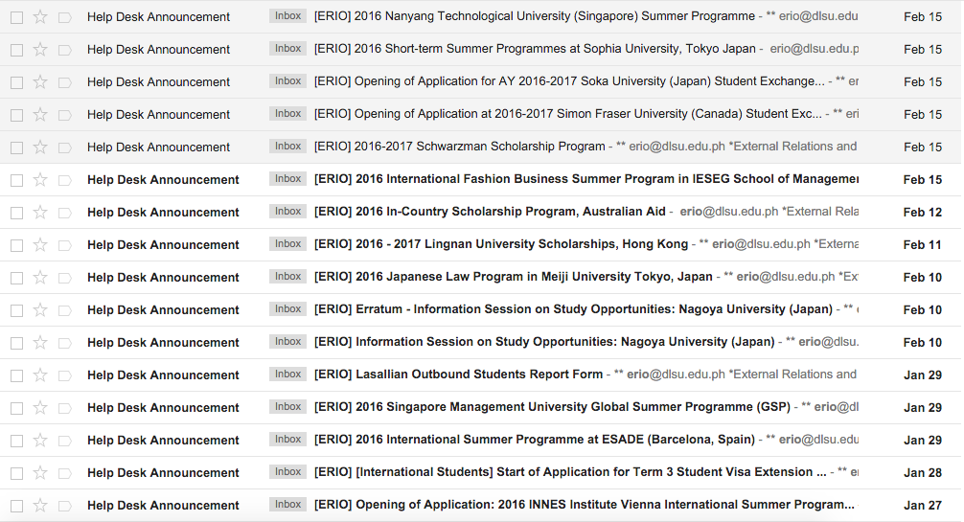

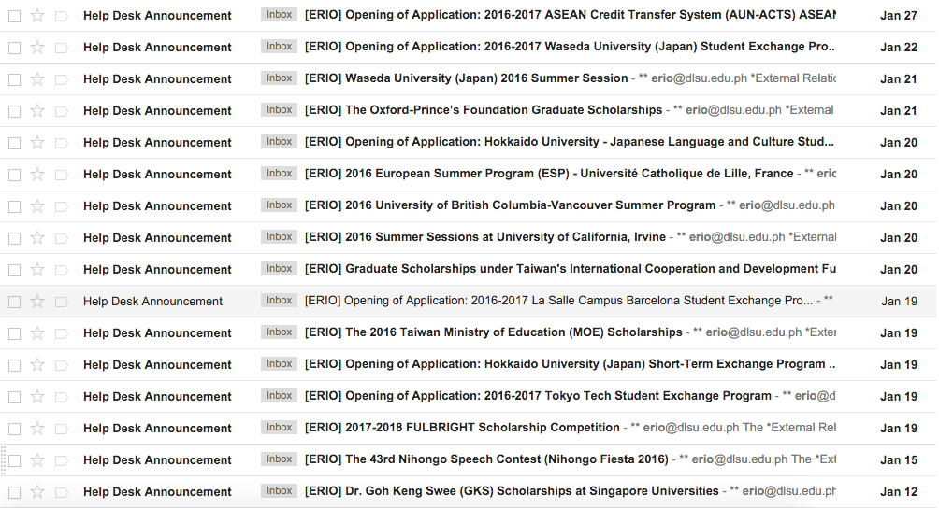

C-2. Office of Career and Counseling Services Publicized Opportunities

The Office of Career and Counseling Services Publicized Opportunities (OCCS) are shared to be able to publicize these opportunities through the main web page of publicizing for the Office of the Vice President for External Affairs (OVPEA) by the Research Manager. The Research Manager does this so that the publicity will reach more people as compared to the people OCCS reaches.

12194932_756382681151663_5654619901287116012_o.jpg



12087260_747807448675853_2378244105657192030_o.jpg

C-3. Office of Career and Counseling Services Company List

The Office of Career and Counseling Services (OCCS) forwards the Company List or the list of companies OCCS has partnership with to the Office of the Vice President for External Affairs (OVPEA). The OVPEA then forwards this list to a Research Manager to be able to look for opportunities from the companies listed.

|  |
| --- |
| ABS-CBN Corporation |
| Accenture, Inc. |
| Advanced World Systems, Inc. |
| AIG Shared Services - Business Processing, Inc. |
| Alpha Aviation Group Philippines |
| Alveo Land |
| ASALUS Corporation (Intellicare) |
| Asia United Bank |
| Ayala Land Sales |
| Azeus Systems Philippines Limited |
| B&M Global Services Manila Inc. |
| Banco de Oro |
| Brittany Corporation |
| Capital One Philippines Support Services Corp. |
| Careers at Ayala Group |
| Cemex |
| China Banking Corporation |
| Chiyoda Philippines Corporation |
| Cisco |
| Citibank |
| Coca-Cola FEMSA Philippines, Inc. |
| Colgate-Palmolive |
| Corporate Executive Search Inc. |
| CPI Outsourcing |
| Daewoo International Corporation |
| De La Salle Santiago Zobel School |
| Del-Monte Philippines |
| Deutsche Bank |
| Deutsche Knowledge Services |
| DLSU AIESEC |
| EastWest Bank |
| Empire East Land Holdings, Inc. |
| Energy Development Corporation |
| FactSet Philippines, Inc. |
| Filinvest Alabang Inc. |
| Filinvest Land Inc. |
| First Balfour, Inc. |
| First Gen Corporation |
| Fly Ace Corporation |
| Fujitsu Philippines, Inc. |
| Gamepark Interactive Entertainment Solution Inc. |
| GlaxoSmithKline Philippines |
| Global-Estate Resorts, Inc. |
| Globe Telecom Inc. |
| Glyphstudios, Inc. |
| Green Bulb PR., Inc. |
| Greenfield Development Corporation |
| GXS (an OpenText company) |
| Honda Philippines, Inc. |
| HSBC |
| i-Tech Global Business Solutions, Inc. |
| IBM Solutions Delivery |
| Indra Philippines |
| ING Global Services and Operation, Inc. |
| Institutional Shareholder Services Inc. |
| International Center for Beginning Beginners |
| International Specialty Concepts, Inc. (Zara) |
| Isla Lipana & Co. |
| Jobs180.com |
| Jollibee Worldwide Services |
| JPMorgan Chase & Co. |
| Kambi Philippines Inc. |
| KFC, Mister Donut, Tokyo Tokyo |
| Kimberly-Clark Philippines, Inc. |
| Klab Cyscorpions Inc. |
| Kumon Philippines, Inc. |
| L'Oreal Philippines |
| Land Bank of the Philippines |
| LF (Philippines), Inc. |
| Lockton Phils. Insurance & Reinsurance Brokers, Inc. |
| Macquarie Offshore Services Pty Ltd. |
| Maersk Global Service Centres |
| Malayan Insurance Co., Inc. |
| Manila Bulletin Publishing Corp. |
| Manila Electric Company (MERALCO) |
| Manly Plastics, Inc. |
| Manpower for Advertising Services Agency, Inc. |
| Manulife |
| Marie France (Beauty Profile Corporation) |
| Megaworld Corporation |
| Metrobank |
| Metrobank Card Corporation |
| Misys Incorporated |
| Monde Nissin Corporation |
| Motolite |
| MSI-ECS Phils. Inc. |
| Navarro Amper & Co. |
| NetworkLabs Inc. |
| One MEGA Group, Inc. |
| Orbium, Inc. |
| Ortigas & Company |
| Pandora Security Labs |
| PAREF Southridge School |
| PAREF Woodrose School |
| Petron Corporation |
| PGA Cars |
| Philippine Geothermal Production Company, Inc. |
| Philippine Long Distance Telephone Company (PLDT) |
| Philippine National Bank |
| Phoenic Petroleum Philippines, Inc. |
| Pointwest Innovations Corporation |
| Primer Group of Companies |
| PRO-FRIENDS |
| RCBC |
| Republic Biscuit Corporation |
| Robinsons Retail Holdings Inc. |
| Rockwell Land Corporation |
| ROHM LSI Design Philippines, Inc. |
| Rustan Commercial Corporation |
| Saint Pedro Poveda College |
| SCG Marketing Philippines |
| Security Bank Corporation |
| SGV & Co. |
| Shell Philippines |
| Shopping Center Management Corporation |
| Siemens, Inc. |
| SilverSky |
| Skillshot Labs |
| Smart Communications, Inc. |
| SNL Information Services, Inc. |
| SSS |
| SSS |
| Standard Chartered Bank |
| State Group of Companies |
| Sterling Bank of Asia |
| Stores Specialists, Inc. |
| Suy Sing Commercial Corporation |
| TDT Global Power Trading |
| Teach for the Philippines |
| Technistock Philippines, Inc. |
| Teradata Philippines |
| TeraSystem, Inc. |
| Terry S.A. Incorporated |
| The Bridge School |
| The British School Manila |
| The Insular Life Assurance Co., Ltd. |
| The Philippine American Life & General Insurance Company (Philam Life) |
| Total (Philippines) Corporation |
| Towers Watson |
| Toyota Motors Philippines Corporation |
| Transnational Diversified Group |
| Unilever Philippines |
| UnionBank of the Philippines |
| Uniqlo |
| United Laboratories, Inc. |
| Vista Land & Lifescapes, Inc. |
| Xurnas, Inc. |
| Zendesk |
| ZMG Ward Howell |

C-4. Office of the Vice President for External Affairs Sample Sign Up Sheet

The Office of the Vice President for External Affairs (OVPEA) Sample Sign Up Sheet is used to monitor the students that have applied to an opportunity with the guidance of OVPEA.

|  |  |  |  |
| --- | --- | --- | --- |
| Student Name | ID Number | Date | Opportunity Name |
|  |  |  |  |
|  |  |  |  |
|  |  |  |  |

**Appendix D – References and Acknowledgement**

### First and Foremost, We would like to express our sincerest gratitude to the Vice President for External Affairs, Levin Garcia, who gave us wholeheartedly co-operation with the system requirements. His and his Office’s warmth and ability to provide answers to inquiries and provide time to be able to make the interviews successful despite the time conflicts we have.

We are also thankful to the Office of Career and Counseling Services and External Relations and Internalization Office who helped us conduct the research for the system requirements despite their busy schedule and work pressure.

We are also thankful to Mr. Briane Samson for his guidance, understanding and the discussions with him to improve on our work.